

**Course: f14/25 - description**

This event is being run on the f14/25 course.

START: on the Wrestlingworth-Guilden Morden road approx. 540 yards, south of Wrestlingworth  
 crossroads and 460 yards north of Common Farm. Proceed south to Guilden Morden where turn **LEFT** (M) 1.95 miles (2nd circuit 13.73 miles) into New Road leading to Shingay cum Wendy and Wendy to T junction 6.34 miles (2nd circuit 18.12 miles) with A1198. At junction bear **LEFT** (**CAUTION**) (M) to roundabout, where bear **LEFT** (M) onto B1042 to Tadlow and cross roads at Wrestlingworth where bear **LEFT** (M) 11.48 miles (2nd circuit 23.26 miles) on unclassified road to Guilden Morden and pass start – Repeat circuit and pass start again and in approx. 1.5 miles to: **FINISH** at south of farm entrance, 50 yards south of Water Hydrant sign and 72 yards north of Bend sign and 149 yards north of large 30 sign. (25 miles

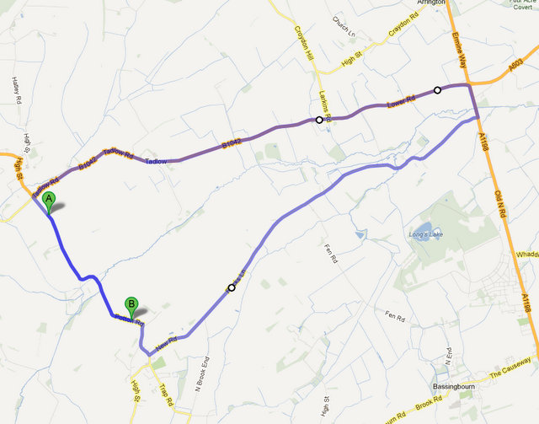

**Headquarters at Steeple Morden Village Hall  
15 Hay Street, Royston, Hertfordshire, SG8 0PD.  
  
 PLEASE NOTE: APROX 4 MILES TO START**

**ALLOW 20 MINS TO START POINT**

**Presents**

## A 2 Up and Solo 25 Mile Time Trial Event

### 31st August 2019

#### Course F14/25

##### **Solo off at 2:01pm, 2UP off at 3:02pm**

**Promoted under Cycling Time Trials Rules and Regulations**

###### Timekeepers: Mike Bannister, Frank Turner.

**Event Secretary: Dan Nickolay/Norma Nickolay**

**105 Ely Close**

**Stevenage**

**Herts**

**SG1 4NR**

**Home 01438 723701**

**Mobile 07770 885990**

**Headquarters address: Steeple Morden Village Hall, 15 Hay Street, Royston, Hertfordshire, SG8 0PD. PLEASE NOTE: APROX 4 MILES TO START - ALLOW 20MINS TO START POINT**

Awards

|  |  |  |  |
| --- | --- | --- | --- |
| Men’s Solo | 1st £20 | 2nd £15 | 3rd £10 |
| Ladies Solo | 1st £20 | 2nd £15 | 3rd £10 |
| 2 UP | 1st £25 | 2nd £20 |  |
| Team Fasted Three | 1st £25 | 2nd £20 | 3rd £15 |

Thanks to all officials, members and friends of Stevenage CC,

without whom this could not take place, and to Emily’s Tea Room,

Whitwell for providing refreshments.